Planning Underway for National Sewing Month 2020

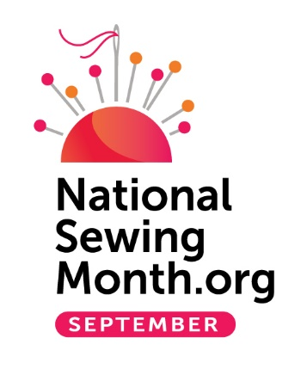
Pittsburgh, PA – November 2019 – Although September is still 10 months away, the Sewing & Craft Alliance (SCA) has already started planning for the 2020 September is National Sewing Month annual celebration. The observance began in 1982 with a proclamation from President Ronald Reagan declaring September as National Sewing Month “in recognition of the importance of home sewing to our Nation.”

During the month of September, sewists gather in fabric stores, sewing lounges, events, schools, meetings and online to celebrate a special month dedicated to the art of and passion for sewing. Since its inception, National Sewing Month has evolved to a month of enthusiasm and fun, celebrating creativity and a spirit of togetherness for active sewists, while also encouraging and inspiring new enthusiasts to take a needle to fabric and experience the thrill of creating or embellishing a project that is their own. In addition, National Sewing Month provides an opportunity for businesses to promote the month with sales, events and classes that drive traffic and turn browsers into shoppers.

SCA partners its promotions with the American Sewing Guild (ASG) a non-profit organization whose mission is to “advance sewing as an art and life skill.” With chapters and neighborhood groups across the country, ASG provides a network of sewing education and support for sewing enthusiasts of all skill levels.

Currently, SCA is in the process of building a new website for National Sewing Month that will debut in the coming months, as well as developing the theme for the 2020 celebration. Sponsorship opportunities will be available to support the efforts to help drive ideas, participation and promotion. Anyone interested in promoting National Sewing Month will be able to visit the www.NationalSewingMonth.org website to download free promotional materials, including logos, flyers, posters, online banners and print-ready ads.

The Sewing & Craft Alliance (SCA) provides education and creative resources to sewing enthusiasts, retailers and educators. SCA offers the free SEW-lutions Education Guidelines and also presents the Trained Sewing Instructor program which provides business training to sewing enthusiasts on becoming a full or part- time sewing instructor. Visit their new websites (currently in development) at www.sewing.org and www.trainedsewinginstructor.com.

######

